Multi-Factor Student Attrition Risk Prediction Using Academic, Engagement, Psychosocial, Environmental Factors

Multimodal Student Engagement Intelligence
Project ID: KND_CDAP_IT_05
Project Proposal Report
Vimukthi H.A.V.C. – IT23191242
B.Sc. (Hons) Degree in Information Technology Specialized in Information Technology
Department of Information Technology
Sri Lanka Institute of Information Technology Sri Lanka
September 2026

DECLARATION
I declare that this is my own work, and this proposal does not knowingly incorporate any material previously submitted for a degree or diploma at any other university or higher education institution, nor does it contain any material that has been previously published or written by another person apart from where proper acknowledgment is given in the text.
Name | Student ID | Signature
Vimukthi H.A.V.C. | IT23191242

The above candidate is conducting research for their undergraduate Dissertation under my supervision.
Name | Date | Signature
Ms. Chathurika Koswatte (Supervisor) | 4/15/2026 | 
Ms. Anuththara Ekanayake (Co-Supervisor) | 4/15/2026 | 

ABSTRACT
Student attrition is still a massive hurdle in higher education today. When students don't finish their degrees, it creates heavy personal, institutional, and economic costs. Looking specifically at the Sri Lankan higher-education context, dropout and disengagement usually stem from a complex mix of academic, behavioral, psychosocial, and socio-economic pressures. Unfortunately, these warning signs are often completely invisible until a student has already fallen too far behind [1], [9]– [11].
As part of a broader four component attrition risk prediction system, this specific component focuses entirely on the behavioral side of that risk: student engagement. Right now, most existing engagement analytics tools like the Moodle Engagement Analytics Plugin depend on a very limited set of static proxies to flag risk, with login frequency being the most common [17], [18]. Similarly, prior machine learning studies that use Learning Management System (LMS) logs mostly rely on basic, aggregated activity counts. They rarely look at the actual evolving patterns of a student's behavior over the course of a semester. This leaves a significant research gap. Current systems simply do not fuse different behavioral modalities into a single engagement signal, and they completely miss the week-on-week "behavioral drift" that almost always happens right before a student fully disengages.
To address this gap, our component creates a comprehensive Multimodal Engagement Index. We achieve this by fusing together LMS activity, quiz attempts, classroom-interaction data, and even mouse-activity logs. Next, we apply clustering and Hidden Markov Modeling to uncover hidden engagement states and track that crucial behavioral drift. For the prediction phase, we train a Gradient Boosting classifier to spot disengagement—benchmarking it against standard Logistic Regression and Random Forest models. We also apply SHAP values to ensure we can clearly explain the exact behavioral drivers behind every single prediction.
We plan to develop this component using an iterative, prototype-driven approach. This allows us to continuously refine our feature engineering as we validate behavioral indicators against real-world LMS data. To evaluate the system, we will use standard classification metrics (accuracy, F1-score, AUC-ROC), paired with a qualitative review of the SHAP explanations by actual teaching staff. Ultimately, the drift alerts and the Multimodal Engagement Index generated here will feed directly into the overarching Attrition Risk Score, working seamlessly alongside the Academic, Psychosocial, and Environmental & Financial components. This provides the complete system with an early, explainable, and deeply behavior-grounded warning signal that goes far beyond just looking at academic performance.

Keywords: Student Engagement, Learning Analytics, Hidden Markov Model, Explainable AI, Behavioral Drift

ACKNOWLEDGEMENT
I would like to express my sincere gratitude to my supervisor, Ms. Chathurika Koswatte, and co supervisor, Ms. Anuththara Ekanayake, for their continuous guidance and feedback throughout the development of this proposal. I also thank my project group members Gunasekara V.S.H., Samarakoon S.M.S.R.K. and Bombugala B.A.C.D. for their collaboration in shaping the overall attrition risk prediction system, and the Sri Lanka Institute of Information Technology for the resources made available for this research.

TABLE OF CONTENT
DECLARATION 2
ABSTRACT 3
ACKNOWLEDGEMENT 4
TABLE OF CONTENT 5
LIST OF TABLES 7
LIST OF FIGURES 8
LIST OF ABBREVIATIONS 9
LIST OF APPENDICES 10
1. INTRODUCTION 11
1.1 Background and Context 11
2. LITERATURE REVIEW 13
2.1 Engagement Prediction from Behavioural and LMS Data 13
2.2 Sequence and State-Based Engagement Modelling 13
2.3 Explainable Machine Learning for Disengagement and Dropout Prediction 13
2.4 Existing Systems and Their Limitations 13
2.5 Research Gap 14
2. OBJECTIVE 15
2.1 Main Objective 15
2.2 Specific Objectives (Engagement Component) 15
3. METHODOLOGY 16
3.1 Research Methodology 16
3.2 Data, Participants and Experimental Inputs 16
3.3 Baseline / Benchmark 16
3.4 Evaluation Metrics 17
3.5 Validation Strategy 17
3.6 Development Approach 17
4. HIGH-LEVEL SYSTEM ARCHITECTURE 18
4.1 Overview of Proposed Solution 18
4.2 Overall Integration 18
4.3 Individual Responsibility Boundary 18
5. USER REQUIREMENTS 20
5.1 Functional Requirements 20
5.2 Non-Functional Requirements 20
6. COMMERCIALIZATION PLAN 22
7. BUDGET AND JUSTIFICATION 23
8. WORK BREAKDOWN STRUCTURE (WBS) 24
9. GANTT CHART 25
10. REFERENCES LIST 26
11. APPENDICES 29
Appendix 1: Prototype Evidence 29
Appendix 2 — Mandatory Proposal Evidence and Decision Log 29
Appendix 3 — AI Use Disclosure 29

LIST OF TABLES
Table 3.4: Evaluation Metrics for the Multimodal Engagement Model
Table 4.3: Individual Responsibility Boundary
Table 7.1: Budget Estimation
Table 9.1: Work Breakdown – Engagement Component

LIST OF FIGURES
Figure 1.1: Fusion of the Four Risk Dimensions into a Single Explainable Attrition Risk Score
Figure 4.1.1: System diagram
Figure 5.1: High-Level System Architecture
Figure 5.2: Engagement Component Pipeline
Figure 9.1.1: Gantt Chart – multimodal student engagement intelligence component
Figure 11.1.1: Prototype 1
Figure 11.1.2: Prototype 2
Figure 11.1.3: Prototype 3
Figure 11.1.4: Prototype 4
Figure 11.1.5: Prototype 5
Figure 11.1.6: Prototype 6

LIST OF ABBREVIATIONS
Abbreviation | Description
LMS | Learning Management System
HMM | Hidden Markov Model
SHAP | SHapley Additive exPlanations
XGBoost | eXtreme Gradient Boosting
MEI | Multimodal Engagement Index
ARS | Attrition Risk Score
AUC-ROC | Area Under the Receiver Operating Characteristic Curve
SUS | System Usability Scale
SDG | Sustainable Development Goal

LIST OF APPENDICES
Appendix 1: Prototype Evidence
Appendix 2: Proposal Evidence and Decision Log
Appendix 3: AI Use Disclosure

1. INTRODUCTION

1.1 Background and Context
Students leaving their degree programs early, commonly known as attrition, is a well-known issue across global higher education. When a student drops out, it is rarely due to just one reason. Instead, it usually happens when academic struggles, coursework disengagement, psychosocial stress, and socio-economic limits all pile up together [2]– [5]. Here in Sri Lanka, these pressures are often much worse. Many undergraduates face deep structural inequalities, like lacking proper devices, stable internet, or a good study environment. In fact, research shows that dropouts across the broader Sri Lankan school and university systems are heavily tied to socio-economic disadvantages and the gap between rural and urban areas [9]– [11].
Our project group is developing a comprehensive attrition-risk system made up of four parts: Academic performance, Engagement, Psychosocial wellbeing, and Environmental & Financial circumstances. This specific component focuses strictly on the Engagement piece. Why engagement? Because it acts as a behavioral footprint. Long before a bad exam grade officially confirms a student is struggling, their institutional systems show the warning signs. If a student starts logging into the LMS less often, skips quizzes, or stops interacting in virtual classes, we can usually spot it weeks before their grades actually drop. This makes behavioral engagement one of the earliest, most actionable red flags for attrition risk.
The problem is that most existing institutional tools treat engagement as just a single, basic proxy. Take the Moodle Engagement Analytics Plugin, for instance. It pulls a few configurable indicators—like logins, forum posts, and submitted assessments—and turns them into a weighted risk percentage for each student [17]. Later studies did confirm that these online activity proxies can successfully identify at-risk learners [18]. Similarly, newer commercial platforms like Solin Early Warning use a basic rules-based design. They simply output a ranked list of vulnerable students without using any actual predictive modeling [19]. These tools are definitely useful, but they rely heavily on manually set thresholds and only look at a very narrow slice of student behavior. Because of this, they lack strong predictive power and struggle to actually explain why a student was flagged in the first place.
To fix this, our component approaches engagement as something that is inherently multidimensional. We don't just look at one metric. Instead, we capture LMS activity, quiz-attempt behavior, live classroom interactions, and even fine-grained details like mouse activity. More importantly, we model this behavior as a continuous trajectory rather than just taking a static snapshot. By doing this, we can actively detect gradual behavioral decline or "drift" long before the student completely disconnects.
On a broader scale, this research directly supports UN Sustainable Development Goal 4 (Quality Education). By accurately identifying struggling students earlier on, we can help provide the support they need to stay engaged, thereby promoting more inclusive and equitable learning opportunities. Within our university's research framework, this work falls under the [Data Science / Software Engineering confirm applicable cluster] cluster. It sits right at the intersection of behavioral data engineering, sequence/state modeling, and explainable machine learning.

2. LITERATURE REVIEW

2.1 Engagement Prediction from Behavioral and LMS Data
When researching student success, the majority of machine learning models rely on LMS trace data as a practical way to measure student engagement. However, taking a broader multimodal approach tends to yield better results. By combining LMS logs, library visits, and forum participation with psychosocial and academic records, researchers can predict both engagement levels and dropout rates much more accurately than they could by relying on academic data alone [14]. Other studies confirm this trend. Mixing actual student behavior (LMS traces) with their psychological traits through validated surveys creates stronger predictions than looking at either dataset by itself [15]. A wider review of multimodal learning analytics shows a clear move away from single-signal tracking toward these fused, multi-source models. Even so, because physiological biosensors are difficult to set up in everyday classrooms, most real-world applications still stick to practical, log-based tracking methods [16].

2.2 Sequence and State-Based Engagement Modelling

Similar Markov-chain methods have also been used to track student behavior during individual assessment sessions. By looking at data on a much tighter timeframe, researchers could map out exactly how learners shift between engaged and disengaged states. To make this work, they first used clustering techniques to clearly define those specific behavioral states, and then modeled the transitions between them [7].

2.3 Explainable Machine Learning for Disengagement and Dropout Prediction

When compared to baseline methods like Logistic Regression and Random Forest, Gradient Boosting models (such as XGBoost, LightGBM, and AdaBoost) consistently stand out as the most accurate tools for classifying student dropout and disengagement. To make these complex predictions easier for academic staff to understand, researchers are increasingly combining them with SHAP values to explain individual outcomes [11], [12]. These ensemble-plus-SHAP methods do a great job of highlighting specific, actionable factors for at-risk students, like their overall activity counts or exactly when they submit assignments. That is exactly why we chose to pair a Gradient Boosting classifier with SHAP for this component, rather than just relying on an unexplainable black-box model [13].

2.4 Existing Systems and Their Limitations
The Moodle Engagement Analytics Plugin takes basic rule-based indicators such as logins, forum posts, and assessment activity and combines them into a single, weighted risk percentage for each course. Several university pilots have already validated this as an effective way to spot at-risk students [17], [18]. On the other hand, newer tools like Solin Early Warning step away from predictive modeling completely. Instead, they provide straightforward, rule-based alerts pulled directly from standard Moodle logs [19].
Despite their usefulness, both of these methods share a major drawback that this component is designed to solve. They basically treat engagement as a handful of separate, threshold-based metrics rather than a unified, learned signal. Crucially, neither approach accounts for "drift." This is the gradual, week-by-week decline in student activity that usually happens right before a complete engagement collapse.

2.5 Research Gap
Looking at the existing literature, most engagement-prediction systems generally fall into one of two categories. They either combine different types of behavioral data but reduce engagement to a single static score, or they track how engagement evolves over time (using techniques like HMMs and clustering) but limit their inputs to just one source, like LMS logs.
So far, none of the reviewed systems bring all these pieces together. We haven't seen a single pipeline that combines multi-modal behavioral data, explicit state-based drift detection, and SHAP-based explainability especially not within the context of Sri Lankan higher education.
Because of this, the specific research gaps this component investigates is clear. Current prediction tools simply do not fuse multi-source behavioral inputs with direct drift tracking to create an early, explainable warning signal for student engagement.

2. OBJECTIVE

2.1 Main Objective
To build and test a system that predicts student attrition risk by combining academic, engagement, psychosocial, and environmental data into one explainable risk score, so that at-risk students can be identified earlier and more accurately than with academic performance alone.

2.2 Specific Objectives (Engagement Component)
- To collect and preprocess multimodal behavioral data LMS activity logs, quiz-attempt logs, classroom-interaction data (Zoom/Teams) and Moodle logs into a unified session-level behavioral dataset.
- To apply clustering and a Hidden Markov Model to session-level behavioral features to discover distinct engagement states (e.g., consistent, declining, sporadic) and detect week-on-week behavior drift.
- To design and train a Gradient Boosting (XGBoost/LightGBM) classifier that uses the discovered engagement states, drift indicators and aggregated behavioral features to predict disengagement, benchmarked against Logistic Regression and Random Forest.
- To apply SHAP to identify the behavioral factors contributing most significantly to attrition risk and to communicate these to non-technical stakeholders (teaching staff).
- To generate and validate a Multimodal Engagement Index (0–100) representing each student's engagement-related attrition risk.
- To integrate the Multimodal Engagement Index into the overall Attrition Risk Score alongside the Academic, Psychosocial, and Environmental & Financial components.

3. METHODOLOGY

3.1 Research Methodology
This study adopts a quantitative, design-science research methodology. We chose this approach because our primary goal is to actually design, build, and empirically evaluate a predictive artifact specifically, the Multimodal Engagement Index and its underlying models. We aren't simply trying to test a traditional social-science hypothesis here.
Several factors justify this methodological choice. First, it perfectly matches our core research question: can multimodal behavioral fusion and drift detection beat single-signal baselines when predicting engagement risk? Second, it suits the specific type of data we are working with, which consists of longitudinal, multi-source behavioral logs. Finally, this direction lines up well with previous research in the field. Most earlier studies on engagement prediction also rely heavily on quantitative, model-comparison methods [6], [11], [12].

3.2 Data, Participants and Experimental Inputs
To build this model, we need several types of session-level behavioral logs. First, this includes standard LMS activity, such as page views, resource access, and overall time-on-task. We also look at quiz-attempt logs to track the number of attempts, time spent, and final scores. Alongside this, we gather classroom interaction data from synchronous platforms like Zoom or Teams, focusing specifically on attendance and engagement counts. Wherever it is feasible, we will even include fine-grained interaction signals, like mouse activity.
These specific sources are ideal because they provide a direct digital footprint of the exact behavior we are trying to model. Even better, since all of this information is naturally collected during normal LMS and virtual classroom operations, we can gather what we need without placing any extra data-collection burden on the students.
- Data source: institutional LMS (Moodle or equivalent), quiz engine logs, video-conferencing platform logs.
- Sample: undergraduate students enrolled Dsa module collected over one full semester.
- Collection method: automated log export from the LMS/quiz engine/conferencing platform, linked to an anonymized student identifier shared across the four project components.
- Preparation process: cleaning, timestamp alignment across sources, aggregation into weekly session-level feature vectors, and handling of missing/irregular activity windows.

3.3 Baseline / Benchmark

To properly evaluate our proposed sequence-and-fusion approach (clustering/HMM + Gradient Boosting + SHAP), we plan to compare it against a few different baselines. First, we will test it against standard Logistic Regression and Random Forest classifiers that have been trained on the exact same aggregated behavioral features. After that, we will also compare it to a much simpler, single-signal baseline. This basic setup will closely resemble the login-and-submission indicator used by the Moodle Engagement Analytics Plugin [17]. Ultimately, running these specific comparisons will help us clearly demonstrate the real added value of using behavioral fusion and drift modeling in the prediction process.

3.4 Evaluation Metrics
Metric | Why Relevant | Target / Comparison
Accuracy | Overall correctness of disengagement classification | Outperform single-signal baseline
F1-score | Balances precision/recall on the minority (at-risk) class | ≥ baseline models
AUC-ROC | Threshold-independent measure of ranking quality for risk scores | ≥ baseline models
SHAP consistency | Stability of top explanatory features across folds | Qualitative review with teaching staff
SUS score | Usability of the resulting dashboard/index for staff | ≥ 68 (average SUS benchmark)
Table 3.4: Evaluation Metrics for the Multimodal Engagement Model

3.5 Validation Strategy
We will validate the model's overall performance by applying stratified k-fold cross-validation to our historical behavioral dataset. To make sure this setup actually mimics a real-world early-warning scenario, we will also use a held-out test set drawn exclusively from the most recent weeks of data.
Beyond just crunching the numbers, we plan to evaluate the SHAP explanations qualitatively alongside academic staff. This step is crucial to confirm that the behavioral factors our system flags are genuinely meaningful and actionable for educators. Taking this extra step aligns perfectly with the accepted best practices for building explainable early-warning systems in the education sector [11]– [13].

3.6 Development Approach
For the development phase, we are taking an Agile, iterative-prototyping approach. We made this choice because we fully expect our behavioral feature set and engagement-state definitions to evolve once we start exploring the actual data. Furthermore, it is crucial to gather regular feedback from teaching staff regarding the SHAP-based explanations. By working in short, iterative cycles, we can continuously incorporate their insights rather than trying to lock down a single, rigid design upfront.

4. HIGH-LEVEL SYSTEM ARCHITECTURE

4.1 Overview of Proposed Solution
Our overall solution brings together four distinct risk dimensions: Academic, Engagement, Psychosocial, and Environmental & Financial. By merging these areas, the system generates a single, easily explainable Attrition Risk Score. Within this broader architecture, the specific component we are building here is responsible for contributing the Multimodal Engagement Index. To actually produce this index, we run the data through a dedicated pipeline. This process handles everything from the initial behavioral data ingestion and engagement-state/drift discovery, right through to disengagement classification and the final SHAP-based explanation.
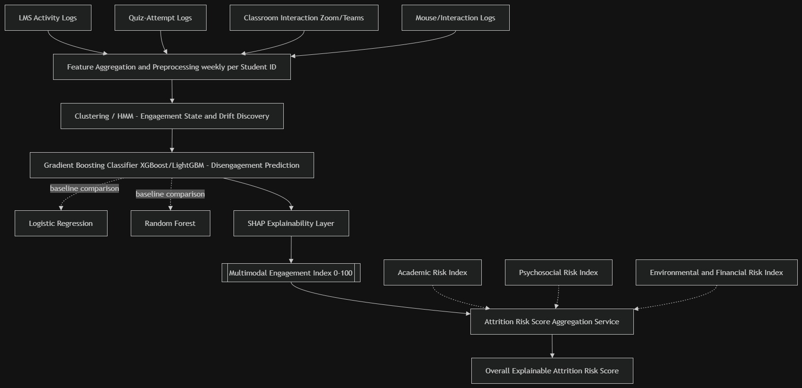
4.1.1. system diagram

4.2 Overall Integration
To seamlessly link all four components, the system relies on a shared, anonymized Student ID. We generate this ID right at the point of user consent. Its sole purpose is to securely merge datasets across our various sub-objectives. Naturally, there are some specific dependencies between these modules. For instance, the Engagement component uses the Academic component's risk scores as an optional confounder-control input. This step is specifically designed for the causal comparisons carried out within the Environmental & Financial component. From there, the system takes the Multimodal Engagement Index and combines it with the other three indices. By applying either, a weighted or learned aggregation, it calculates the final Attrition Risk Score. From a technical standpoint, we plan to handle this integration by utilizing a shared internal data schema. Each individual component will expose a common scoring API, allowing a central scoring service to easily pull and aggregate the final results.

4.3 Individual Responsibility Boundary
Activity / Deliverable | My Responsibility | Shared Responsibility | Other Member
Multimodal behavioural data collection & preprocessing | ✓
Clustering / HMM engagement-state & drift discovery | ✓
Gradient Boosting disengagement classifier & SHAP explainability | ✓
Multimodal Engagement Index generation & validation | ✓
Shared Student ID schema & data-merging convention |  | ✓
Overall Attrition Risk Score aggregation service |  | ✓
Academic Risk Index (LSTM/GRU trajectory model) |  |  | Gunasekara V.S.H.
Psychosocial Risk Index (survey + RF/XGBoost) |  |  | Samarakoon S.M.S.R.K.
Environmental & Financial Risk Index / Causal Forest analysis |  |  | Bombugala B.A.C.D.
Table 4.3: Individual Responsibility Boundary

5. USER REQUIREMENTS

To define the exact requirements for this component, we relied on a combination of three main strategies. First, we conducted informal consultations with teaching staff specifically those who currently spend their time manually reviewing Moodle activity reports. Alongside these discussions, we also observed how existing engagement-analytics tools, such as the Moodle Engagement Analytics Plugin, are actually being used in practice. Finally, we backed up these real-world observations with a thorough review of prior studies focused on learning-analytics dashboards [17], [18], [31]. By gathering insights from all of these different sources, we were able to clearly map out the specific functional and non-functional requirements detailed below.

5.1 Functional Requirements
- FR1: The system shall ingest and align LMS, quiz-attempt and classroom-interaction logs for each enrolled student on a weekly basis.
- FR2: The system shall cluster students into distinct engagement states (e.g., consistent, declining, sporadic) based on aggregated behavioral features.
- FR3: The system shall apply a Hidden Markov Model to detect week-on-week behavior drift for each student.
- FR4: The system shall classify each student's disengagement risk using a Gradient Boosting model benchmarked against Logistic Regression and Random Forest.
- FR5: The system shall generate a Multimodal Engagement Index (0–100) per student, updated on a rolling weekly basis.
- FR6: The system shall produce a SHAP-based explanation for each student's engagement-risk score, identifying the top contributing behavioral factors.
- FR7: The system shall expose the Multimodal Engagement Index to the shared Attrition Risk Score aggregation service via a defined API/schema.

5.2 Non-Functional Requirements
- NFR1 (Performance): Weekly index recalculation for a full course cohort shall complete within 20 minutes.
- NFR2 (Usability): SHAP explanations shall be presentable to non-technical academic staff without requiring machine-learning expertise; target SUS score ≥ 68.
- NFR3 (Security): Behavioral logs and derived indices shall be linked only via an anonymized Student ID and access-controlled to authorized staff.
- NFR4 (Reliability): The pipeline shall handle missing or irregular log data for a given week without failing index generation for other students.
- NFR5 (Scalability): The pipeline shall scale to at least 50 concurrently enrolled students without redesign.
- NFR6 (Accessibility): Any staff-facing dashboard output shall conform to WCAG 2.1 AA color contrast guidelines, so risk indicators are distinguishable without relying on color alone.

6. COMMERCIALIZATION PLAN
- Target market and customer persona: Sri Lankan and regional higher-education institutions, represented by academic administrators, course coordinators and student-welfare/counselling units seeking earlier behavioral risk signals than existing LMS reports provide.
- Value proposition: a single, explainable engagement-risk score fused from multiple behavioral sources, with SHAP-based reasons for each flag, reducing reliance on manually configured, single-signal thresholds.
- Revenue model: institutional SaaS subscription (per-student or per-cohort licensing), integrated as an add-on module to existing LMS deployments (e.g., Moodle,courseweb).
- Cost estimation: primarily cloud compute/storage for model training and inference, plus ongoing maintenance of LMS/API integrations.
- Pricing strategy: tiered pricing by student headcount, with a reduced introductory tier for pilot institutions.
- Competitive advantage: multimodal behavioral fusion and explicit drift detection, versus competitors' single-signal, rule-based indicators (e.g., Moodle Engagement Analytics Plugin, Solin Early Warning) [17], [19].
- Intellectual property considerations: the trained models, feature-engineering pipeline and index-generation methodology would be retained as proprietary IP, with any third-party libraries (XGBoost, SHAP, hmmlearn) used under their respective open-source licenses.

7. BUDGET AND JUSTIFICATION
Item | Estimated Cost (LKR) | Justification
Cloud compute (model training/inference) | Rs.5000 | Training clustering/HMM and Gradient Boosting models on multi week behavioral logs.
Cloud storage | Rs.20,000 | Storing raw and processed multimodal behavioral logs securely.
Software licenses / APIs | Rs.6000 | Any paid classroom-interaction (Zoom/Teams) API access needed for interaction logs.
Human effort (development time) | Rs.0 | Student development effort across data engineering, modelling and evaluation.
Contingency | Rs.2000 | Buffer for additional data-cleaning or re-training cycles.
Estimated Cost | Rs.33,000 | All the cost
Table 7.1: Budget Estimation

8. WORK BREAKDOWN STRUCTURE (WBS)
# | Task | Duration | Depends On | Deliverable
1.1 | Review engagement & drift-detection literature | 3 wks (W1–W3) | — | Annotated literature summary
1.2 | Define research gap & specific objectives | 3 wks (W2–W4) | 1.1 | Gap statement (feeds Ch.2)
2.1 | Collect LMS / quiz / classroom-interaction logs | 4 wks (W4–W7) | 1.2 | Raw behavioral dataset
2.2 | Clean logs & align timestamps across sources | 2 wks (within W4–W7) | 2.1 | Aligned event log
2.3 | Aggregate into weekly session-level feature vectors | 1 wk (end of W7) | 2.2 | Feature-engineered dataset
3.1 | Cluster students into engagement states | 2 wks (W6–W9, w/ baselines) | 2.3 | Engagement-state labels
3.2 | Apply HMM for week-on-week drift detection | 3 wks (W7–W12) | 3.1 | Drift indicator per student
3.3 | Train baseline models (Logistic Regression, Random Forest) | 3 wks (W6–W9) | 2.3 | Baseline performance benchmark
3.4 | Train Gradient Boosting disengagement classifier | 4 wks (W8–W12) | 3.1, 3.2, 3.3 | Trained GB model
4.1 | Compute SHAP values for the GB model | 2 wks (W10–W13) | 3.4 | Feature-attribution set
4.2 | Generate & validate Multimodal Engagement Index (0–100) | 2 wks (W11–W13) | 4.1 | Multimodal Engagement Index
5.1 | Implement shared Student-ID schema | 1 wk (W12–W13) | 4.2 | Shared data-merge convention
5.2 | Expose index via API to Attrition Risk Score service | 2 wks (W13–W15) | 5.1 | Integrated scoring API
5.3 | Unit & pipeline testing | 2 wks (W12–W14) | 4.2 | Test report
6.1 | Evaluate using Accuracy / F1 / AUC-ROC | 1 wk (W14–W15) | 5.3 | Evaluation metrics table
6.2 | Review SHAP explanations with teaching staff (SUS) | 1 wk (W14–W15) | 4.1 | Usability/validity feedback
6.3 | Final report writing & consolidation | 4 wks (W13–W16) | 6.1, 6.2 | Completed proposal report
Table 8.1: Work Breakdown – Engagement Component

9. GANTT CHART
The Gantt chart below assumes a 16-week timeline; adjust the week numbers to match your actual semester calendar.
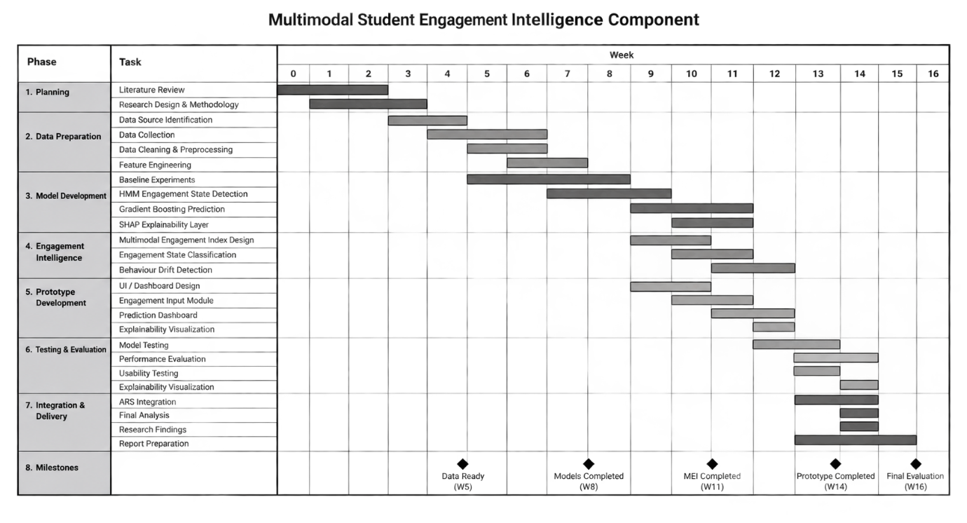
9.1.1. Gantt Chart – multimodal student engagement intelligence component

10. REFERENCES LIST
[1] S. Haarika and K. Srinivas, “Student dropout prediction using machine learning techniques,” International Journal of Intelligent Systems and Applications in Engineering, 2022. [Online]. Available: https://www.researchgate.net/publication/377210513_STUDENT_DROPOUT_PREDICTION_USING_MACHINE_LEARNING
[2] “Predicting Student Dropout based on Machine Learning and Deep Learning: A Systematic Review,” EAI Endorsed Transactions on Scalable Information Systems, 2023. [Online]. Available: https://publications.eai.eu/index.php/sis/article/view/3586
[3] “Machine Learning and Deep Learning for Dropout Prediction in Higher Education: A Review,” MDPI, 2026. [Online]. Available: https://www.mdpi.com/2073-431X/15/3/164
[4] “Predicting student dropouts with machine learning: An empirical study in Finnish higher education,” ScienceDirect, 2024. [Online]. Available: https://www.sciencedirect.com/science/article/pii/S0160791X24000228
[5] “Supervised machine learning algorithms for predicting student dropout and academic success: a comparative study,” Discover Artificial Intelligence, Springer Nature, 2024. [Online]. Available: https://link.springer.com/article/10.1007/s44163-023-00079-z
[6] S. López-Pernas and M. Saqr, “Mining patterns and clusters with transition network analysis: a heterogeneity approach,” in Proc. LAK, Springer, 2025. [Online]. Available: https://link.springer.com/chapter/10.1007/978-3-031-95365-1_17
[7] R. Maqsood et al., “Modeling and predicting students’ engagement behaviors using mixture Markov models,” Knowledge and Information Systems, Springer, 2022. [Online]. Available: https://link.springer.com/article/10.1007/s10115-022-01674-9
[8] “The longitudinal association between engagement and achievement varies by time, students’ profiles, and achievement state: A full program study,” Computers & Education, ScienceDirect, 2023. [Online]. Available: https://www.sciencedirect.com/science/article/pii/S0360131523000647
[9] “The longitudinal trajectories of online engagement over a full program,” Computers & Education, 2021. [Online]. Available: https://dl.acm.org/doi/10.1016/j.compedu.2021.104325
[10] “Detection of Disengagement from Voluntary Quizzes: An Explainable Machine Learning Approach in Higher Distance Education,” arXiv:2507.02681, 2025. [Online]. Available: https://arxiv.org/html/2507.02681
[11] “A Modular and Explainable Machine Learning Pipeline for Student Dropout Prediction in Higher Education,” Algorithms (MDPI), vol. 18, no. 10, 2025. [Online]. Available: https://doi.org/10.3390/a18100662
[12] “Ex-ADA: a SHAP-based explainable AdaBoost framework for predicting at-risk students,” Frontiers in Education, 2025. [Online]. Available: https://www.frontiersin.org/journals/education/articles/10.3389/feduc.2025.1728070/full
[13] “Ensemble machine learning framework with SHAP and LIME for accurate outcome prediction,” Scientific Reports, Nature, 2026. [Online]. Available: https://www.nature.com/articles/s41598-026-49894-1
[14] “Multimodal machine learning framework for predicting and enhancing higher education using reinforcement learning and graph neural networks,” Informatica, Taylor & Francis, 2025. [Online]. Available: https://www.tandfonline.com/doi/full/10.1080/00051144.2025.2565023
[15] “Leveraging psychological data and transparent machine learning for student success prediction in digital learning systems,” ScienceDirect, 2026. [Online]. Available: https://www.sciencedirect.com/science/article/pii/S2772503026000411
[16] “Enhancing Online Learning by Integrating Biosensors and Multimodal Learning Analytics for Detecting and Predicting Student Behavior: A Review,” arXiv:2509.07742, 2025. [Online]. Available: https://arxiv.org/pdf/2509.07742
[17] “Engagement Analytics Plugin,” MoodleDocs. [Online]. Available: https://docs.moodle.org/22/en/Engagement_Analytics_Plugin
[18] D. Liu, C. Froissard, A. Atif, and D. Richards, “Validating the Effectiveness of the Moodle Engagement Analytics Plugin to Predict Student Academic Performance,” ASCILITE, 2015. [Online]. Available: https://www.researchgate.net/publication/281073002_Validating_the_Effectiveness_of_the_Moodle_Engagement_Analytics_Plugin_to_Predict_Student_Academic_Performance
[19] “Identify At-Risk Students in Moodle Early — Solin Early Warning,” Solin. [Online]. Available: https://solin.co/guide-identify-students-at-risk-moodle/
[20] “Addressing the Complex Challenges Faced by Developing Countries in Achieving Educational Equity for Disadvantaged Youth in Tertiary Education: A Case Study of Sri Lanka,” 2025. [Online]. Available: https://pub.analytrics.org/article/21/
[21] “Determinants of school drop-out among adolescents in rural Sri Lanka,” ScienceDirect, 2024. [Online]. Available: https://www.sciencedirect.com/science/article/abs/pii/S0190740924006844
[22] “School Dropouts in Sri Lanka: A Sociological Analysis,” ResearchGate. [Online]. Available: https://www.researchgate.net/publication/311887011_School_Dropouts_in_Sri_Lanka_A_Sociological_Analysis

11. APPENDICES

Appendix 1: Prototype Evidence

Expected Wireframes for the mobile application to be implemented

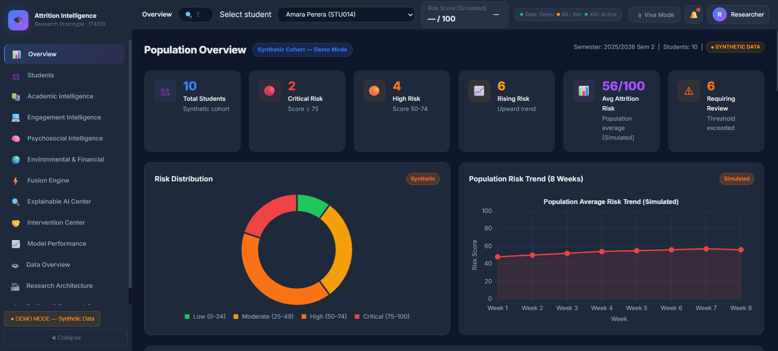
Figure 11.1.2: Prototype 1

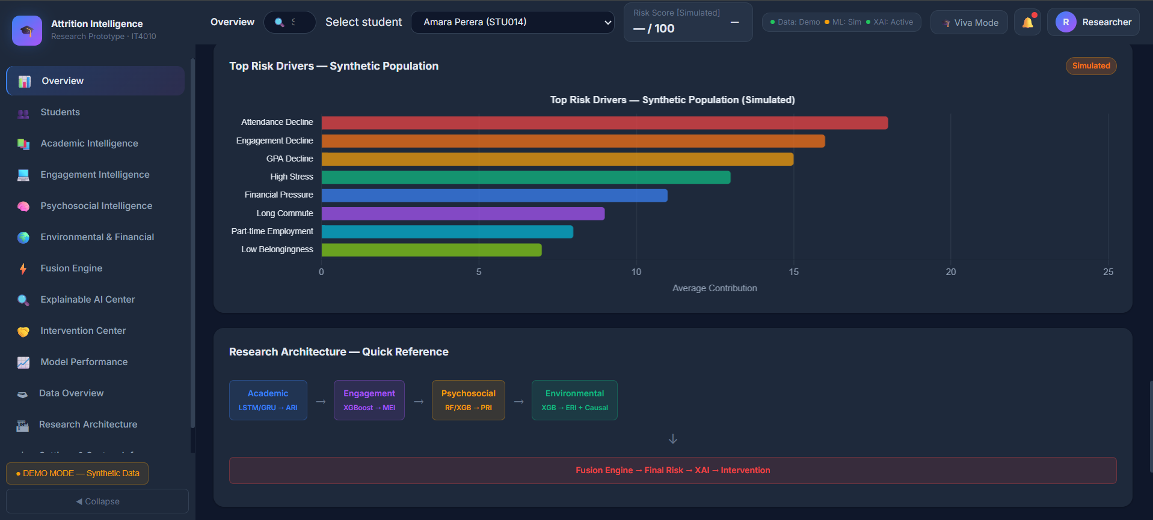
Figure 11.1.3: Prototype 2

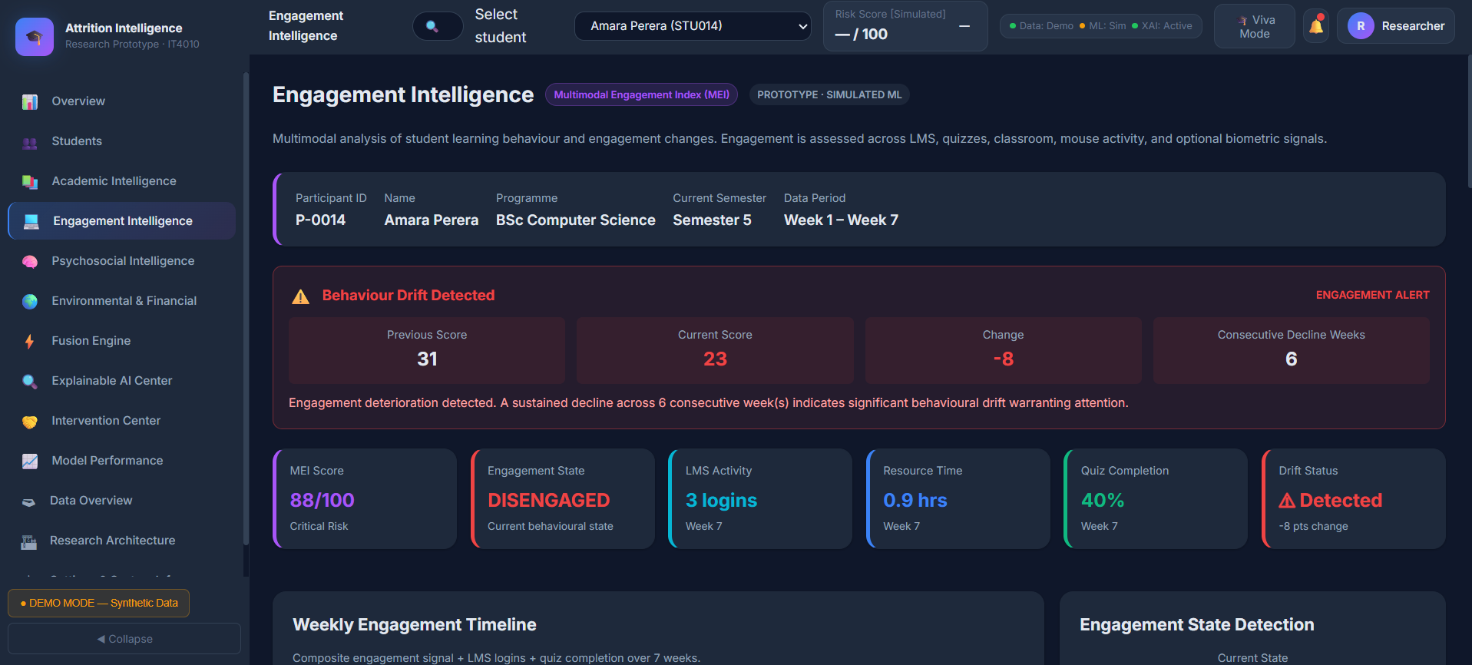
Figure 11.1.4: Prototype 3

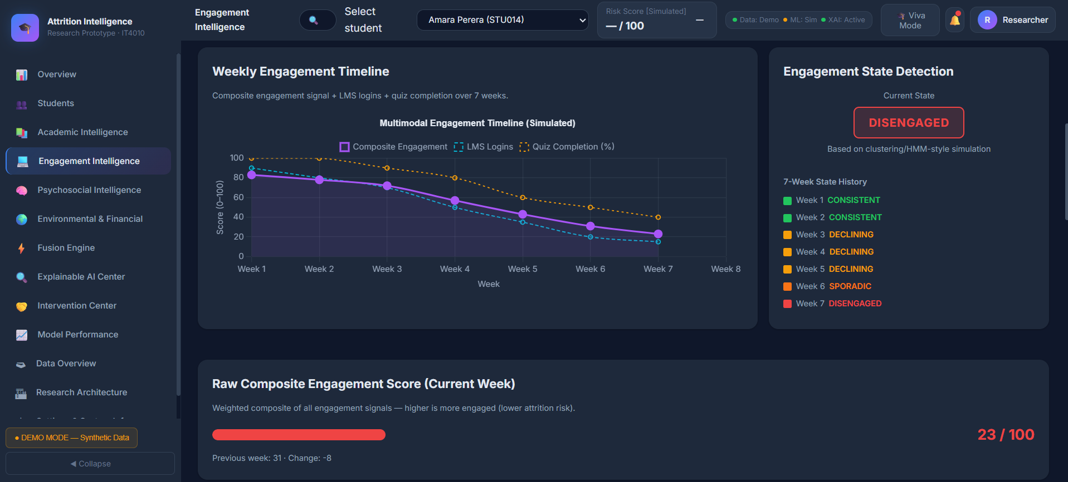
Figure 11.1.5: Prototype 4

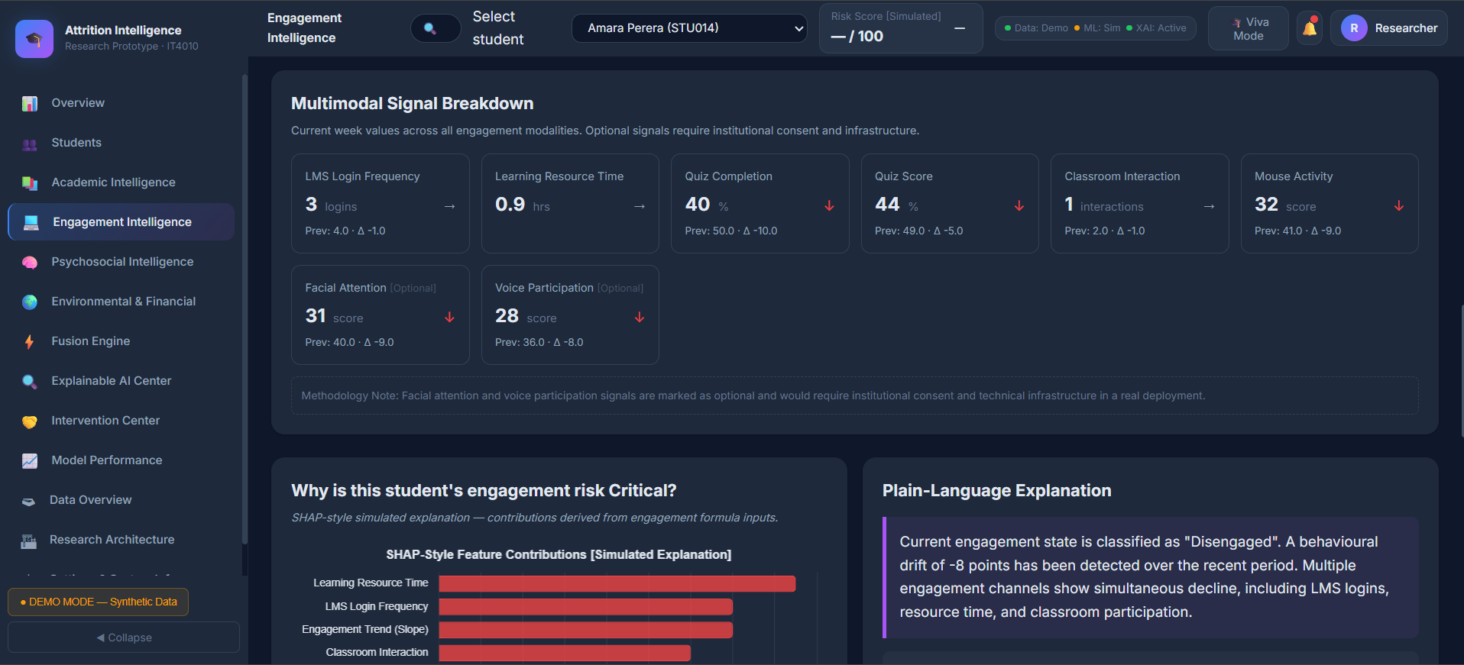
Figure 11.1.5: Prototype 5

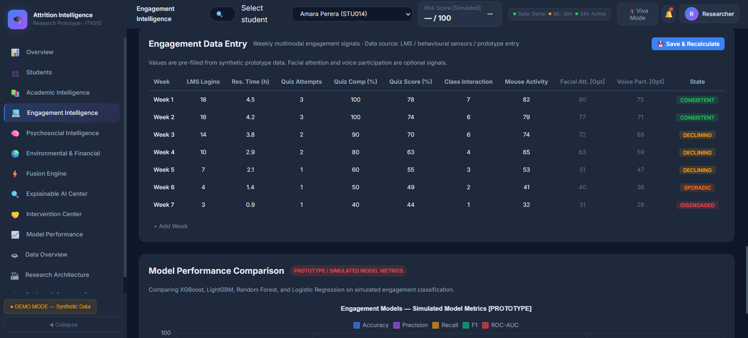
Figure 11.1.6: Prototype 6

Appendix 2 — Mandatory Proposal Evidence and Decision Log
Date | Claim / Problem | Evidence Collected | Alternatives Considered | Decision Made | Supervisor Discussion
7/6/2026 | Confirming the scope of the Engagement component against the group's Research Topic Assessment Form | Approved TAF objectives table (clustering/HMM engagement states, Gradient Boosting classifier, SHAP, Multimodal Engagement Index) | Treating engagement as a single aggregated LMS-activity score vs. a multimodal, state-based model | Adopted the multimodal, trajectory-based design already approved in the TAF: LMS + quiz + classroom-interaction + mouse-activity fusion with HMM-based drift detection | Ms. Koswatte confirmed the multimodal, trajectory-based design matches what was approved in the TAF and does not need re-submission, but asked that the conceptual diagram in Chapter 4 clearly show how this component's output feeds the shared fusion layer
18/6/2026 | Which behavioral data sources are feasible and appropriate to collect for engagement modelling | Institutional LMS log export fields; quiz-engine attempt logs; classroom-platform (Zoom/Teams) attendance and interaction count | (a) LMS logs only; (b) LMS + quiz + classroom logs; (c) LMS + quiz + classroom + biometric sensors (webcam facial-expression / voice-tone capture) | Selected option (b): LMS, quiz-attempt, classroom-interaction, and mouse-activity logs. Facial-expression and voice data were excluded from the component entirely | Both supervisors agreed LMS, quiz, and classroom-interaction logs are readily available through existing institutional systems; Ms. Ekanayake flagged that mouse-activity logging may need a lightweight browser script or plugin, and asked for a fallback plan if that data proves hard to capture at scale
7/7/2026 | Whether facial expression or voice-based emotion/engagement detection should be included, given ethical-clearance and privacy requirements for biometric data | University research-ethics guidance on collecting biometric/personally identifying data from students; workload and consent implications of camera/microphone-based capture | Include webcam- and voice-based affect detection for richer signal vs. restrict to non-biometric behavioral logs | Removed facial expression and voice data from the component's scope entirely to avoid biometric data-collection and the additional ethical-clearance burden this would require; retained only non-biometric, already-institutionally-collected log data | Ms. Koswatte agreed that excluding biometric data was the right call, noting it would have required a full ethics-board review and separate informed-consent process that the project timeline could not accommodate; she asked that this reasoning be stated explicitly in the proposal so examiners understand it was a deliberate scope decision, not an oversight
11/7/2026 | Ethical clearance requirements for the behavioral data that remains in scope (LMS/quiz/classroom/mouse-activity logs) | SLIIT research-ethics review process for studies using existing institutional log data linked to students | Full ethics board review vs. expedited review, given no biometric or sensitive personal data is collected | Plan to apply for ethical clearance under the expedited/minimal-risk category, using an anonymized Student ID shared only across the four components and no biometric data collection | Ms. Koswatte confirmed the expedited/minimal-risk category is appropriate since the data is anonymized and non-biometric, but asked that the ethics application explicitly state that the Student ID mapping key is stored separately from the behavioural dataset
14/7/2026 | Which unsupervised method to use for discovering engagement states before drift modelling | Prior literature using k-means and Gaussian Mixture Models on LMS behavioural features; mixture-HMM studies clustering first, then modelling transitions | K-means (hard clusters) vs. Gaussian Mixture Model (soft/probabilistic clusters) vs. skipping clustering and feeding raw features directly into the HMM | Adopted a Gaussian Mixture Model to define soft engagement states, since student behavior rarely falls cleanly into one state and probabilistic membership better supports downstream drift detection | Ms. Koswatte agreed GMM was appropriate given the soft-boundary nature of engagement, but asked for a sensitivity check on the number of states (k) before finalizing
28/7/2026 | Why Gradient Boosting was chosen as the primary classifier over the two baselines | Benchmark comparisons in reviewed literature showing XGBoost/LightGBM consistently outperforming Logistic Regression and Random Forest on similar tabular behavioural-log tasks | Using Random Forest as the primary model (simpler, easier to explain) vs. Gradient Boosting (typically higher accuracy, more tuning required) | Selected Gradient Boosting (XGBoost/LightGBM) as the primary model, keeping Logistic Regression and Random Forest strictly as benchmark baselines to justify the added complexity | Ms. Koswatte asked for the performance gap over Random Forest to be reported explicitly in the evaluation chapter, to justify the extra model complexity to examiners
1/8/2026 | Whether to use SHAP or LIME for explaining individual disengagement predictions | Literature comparing SHAP's consistency/theoretical grounding (Shapley values) against LIME's local surrogate-model approach | SHAP vs. LIME vs. reporting only global feature importance (no per-student explanation) | Selected SHAP for its consistency across predictions and because teaching staff need per-student, not just global, explanations | Ms. Koswatte confirmed SHAP was preferable since the Psychosocial component was also using SHAP, keeping explanation format consistent across the group's shared explanation layer

Appendix 3 — AI Use Disclosure
AI Tool | Purpose of Use | What Was Generated/Assisted | How Output Was Verified | Final Student Contribution
Claude | Gantt chart search assistance | Gantt templates
The use of AI does not transfer responsibility for the submitted work. I remain responsible for accuracy, originality, validity of references, research decisions, methodology, technical choices, interpretation of evidence, and the ability to defend every part of the proposal.

